Practical – 5
Write a program to demonstrate the working of the decision tree based ID3 algorithm. Use an appropriate data set for building the decision tree and apply this knowledge to classify a new sample.

1. What is Decision Tree?
Decision Trees (DTs) are a non-parametric supervised learning method used for classification and regression. The goal is to create a model that predicts the value of a target variable by learning simple decision rules inferred from the data features. A tree can be seen as a piecewise constant approximation.
It splits the dataset into smaller subsets based on feature values, forming a structure similar to a flowchart.
- Internal Nodes → Represent decision based on an attribute
- Branches → Represent outcome of the decision
- Leaf Nodes → Represent final class label Decision Trees are easy to understand and interpret.
- What is ID3 Algorithm?
ID3 (Iterative Dichotomiser 3) is a Decision Tree algorithm developed by Ross Quinlan.
It is mainly used for classification problems.
The ID3 algorithm builds the tree by selecting the best attribute using Information Gain.
- Core Concept of ID3
ID3 uses two important concepts:
- Entropy
Entropy measures the impurity or randomness in the dataset.

Formula:
Entropy(S)=−∑pilog⁡2piEntropy(S) = - \sum p_i \log_2 p_iEntropy(S)=−∑pi log2pi
Where:
  - pip_ipi = Probability of class i
  - If entropy = 0 → Data is pure
  - If entropy = 1 → Data is highly impure
- Information Gain
Information Gain tells us how much information a feature gives about the class.
Formula:
InformationGain=Entropy(S)−∑SvSEntropy(Sv)Information Gain =
Entropy(S) - \sum \frac{|S_v|}{|S|}
Entropy(S_v)InformationGain=Entropy(S)−∑SSvEntropy(Sv) Where:
  - S = Original dataset
  - SvS_vSv = Subset after splitting on attribute
The attribute with the highest Information Gain is selected as the root node.
- How ID3 Algorithm Works?
Core Idea:
  - Start with the complete dataset
  - Calculate entropy of dataset
  - Calculate Information Gain for each attribute
  - Select the attribute with highest Information Gain
  - Split the dataset based on that attribute
  - Repeat the process for each subset
  - Stop when:
o All samples belong to same class OR No attributes are left
The final result is a fully constructed decision tree.
- Steps of ID3 Algorithm Implementation
Step 1: Dataset Preparation
Select an appropriate classification dataset containing multiple attributes and a target class label. import pandas as pd import numpy as np from math import log2

dataset = {
'Outlook': ['Sunny','Sunny','Overcast','Rain','Rain','Rain','Overcast',
'Sunny','Sunny','Rain','Sunny','Overcast','Overcast','Rain'],
'Temp': ['Hot','Hot','Hot','Mild','Cool','Cool','Cool',
'Mild','Cool','Mild','Mild','Mild','Hot','Mild'],
'Humidity': ['High','High','High','High','Normal','Normal','Normal',
'High','Normal','Normal','Normal','High','Normal','High'],
'Wind': ['Weak','Strong','Weak','Weak','Weak','Strong','Strong',
'Weak','Weak','Weak','Strong','Strong','Weak','Strong'],
'Play': ['No','No','Yes','Yes','Yes','No','Yes',
'No','Yes','Yes','Yes','Yes','Yes','No']
}

df = pd.DataFrame(dataset)
print(df)
Output:
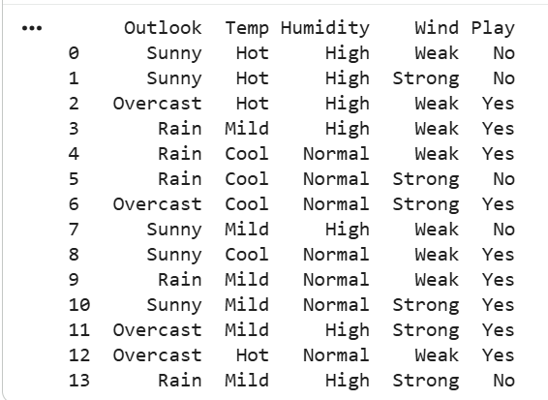
Step 2: Calculate Entropy
Compute entropy for the entire dataset to measure impurity. def entropy(target_col):
values, counts = np.unique(target_col,return_counts=True)
entropy_value = 0
for i in range(len(values)):
p = counts[i] / sum(counts)
entropy_value -=p * log2(p)
return entropy_value
print("Entropy of dataset:", entropy(df['Play']))

Output:
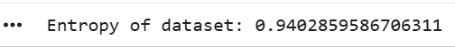
Step 3: Calculate Information Gain For each attribute:
- Split dataset based on attribute values
- Calculate entropy of each subset
- Compute Information Gain
Select the attribute with highest gain.
def information_gain(data, feature, target="Play"):
total_entropy = entropy(data[target])
values, counts = np.unique(data[feature], return_counts=True)
weighted_entropy = 0
for i in range(len(values)):
subset = data[data[feature] == values[i]]
weighted_entropy += (counts[i] / sum(counts)) * entropy(subset[target])
return total_entropy - weighted_entropy
for col in df.columns[:-1]:
print(col, ":", information_gain(df, col))
Output:
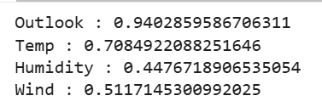
Step 4: Build the Tree
- Make selected attribute as root node
- Create branches for each possible value
- Recursively repeat the process for each branch
def id3(data, original_data, features, target="Play", parent_node=None):
if len(np.unique(data[target])) <= 1:
return np.unique(data[target])[0]
elif len(data) == 0:
return(np.unique(original_data[target])[np.argmax(np.unique(original_data[target], return_counts=True)[1])])
elif len(features) == 0:
return parent_node
else:
parent_node=np.unique(data[target])[np.argmax(np.unique(data[target],return_counts=True)[1])]
gains = [information_gain(data, feature, target) for feature in features]
best_feature = features[np.argmax(gains)]
tree = {best_feature: {}}
features = [f for f in features if f != best_feature] for value in np.unique(data[best_feature]):
sub_data = data[data[best_feature] == value]
subtree = id3(sub_data, original_data, features, target,
parent_node)
tree[best_feature][value] = subtree
return tree
Step 5: Stopping Criteria
Stop building the tree when:
- All samples in subset belong to same class
- No attributes are available
- Dataset becomes empty
features = df.columns[:-1].tolist()
tree = id3(df, df, features)
print("Decision Tree:") print(tree)
Output:
Step 6: Classification of New Sample To classify a new sample:
- Start from root node
- Follow the branch according to feature value
- Continue until reaching a leaf node
- The leaf node represents predicted class

def predict(query, tree):
for key in list(query.keys()):
if key in tree:
value = query[key] subtree = tree[key][value] if isinstance(subtree, dict):
return predict(query, subtree)
else:
return subtree
new_sample = {
'Outlook': 'Rain',
'Temp': 'Mild',
'Humidity': 'High',
'Wind': 'Weak'
}
result = predict(new_sample, tree) print("Prediction:", result)
Output:

- Advantages of ID3
  - Simple and easy to understand
  - Works well with categorical data
  - No need for data normalization
  - Fast computation
- Limitations of ID3
  - Can overfit the training data
  - Cannot handle continuous data directly
  - Biased toward attributes with many values
  - No pruning mechanism
- Applications of Decision Tree (ID3)
  - Medical diagnosis
  - Customer classification
  - Spam detection
  - Credit risk analysis
  - Weather prediction
Conclusion
The ID3 algorithm is a popular Decision Tree method used for classification tasks. It constructs a tree structure using Entropy and Information Gain to select the best attributes. The generated tree can be used to classify new samples by traversing from root to leaf node.

